#GOROGUE Hasbro Checklist

September 30th, 2016 12:01 AM

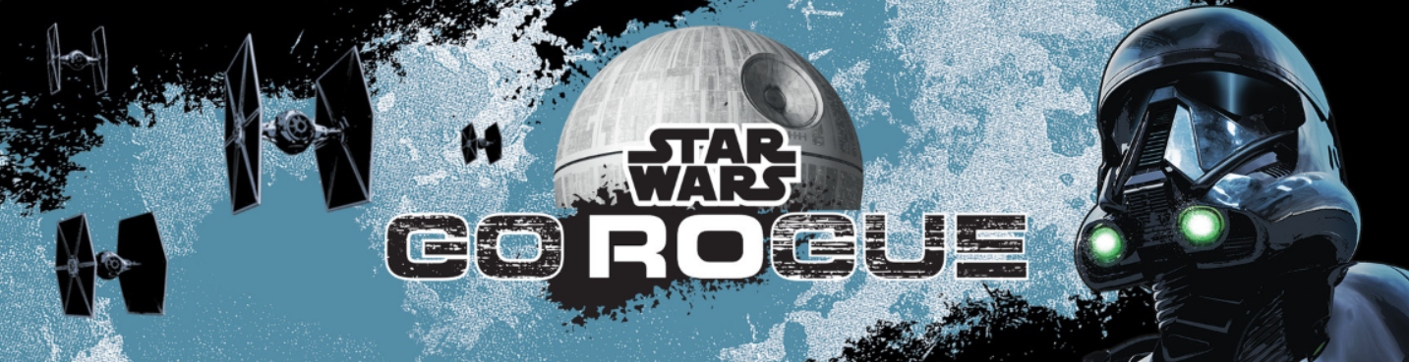

Participating Midnight Madness Retailers:
All Toys ‘R’ Us Stores (Exclusive Collector Poster and T-Shirt)

Preorders are available on the following items:
- Sergeant Jyn Erso (Jedha) [The Black Series]
- Rebel U-Wing Fighter with Captain Cassian Andor [Rogue One]
- Imperial Stormtrooper Helmet [The Black Series]

TOY RUN: The Star Wars Action Figure Cast – The only podcast devoted exclusively to Star Wars action figures
From4-LOMtoZuckuss.com - A website for all things Star Wars Action Figure related
Jedibusiness.com – The largest Star Wars Action Figure database on the internet
Galaxy of Toys Podcast - A discussion about Star Wars Toys Vintage to Modern

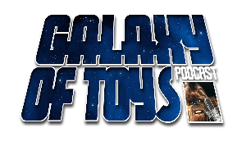

Rogue One

~ 3 ¾” Basic Figures ~
Wave 1

- Imperial Ground Crew
- Imperial Stormtrooper
- K-2SO
- Kanan Jarrus (Stormtrooper Disguise)
- Kylo Ren
- Sabine Wren
- Sergeant Jyn Erso (Eadu)

Wave 2
- Captain Cassian Andor (Eadu)
- Chirrut Imwe
- Darth Vader
- Director Krennic
- Princess Leia Organa
- Rey (Jakku)
- Sergeant Jyn Erso (Jedha)

Wave TBA

- Fenn Rau
- Grand Admiral Thrawn

~ 3 ¾” Deluxe 2-Packs ~
Wave 1
- Poe Dameron & First Order Snowtrooper Officer
- Imperial Death Trooper & Rebel Commando Pao
- Scariff Stormtrooper Squad Leader & Moroff

Wave 2

- Blaze Malbus & Imperial Stormtrooper
- Seventh Sister Inquisitor & Darth Maul

~ 3 ¾” Vehicles with Figures ~
Class I

- Ezra Bridger’s Speeder with Ezra Bridger
- First Order Assault Walker with Stormtrooper Sergeant
- Imperial Speeder with AT-DP Pilot

Class I Deluxe

- Rey’s Speeder (Jakku) with Rey (Jakku)
- Y-Wing Scout Bomber with Kanan Jarrus

Class II

- First Order Snowspeeder with First Order Snowtrooper Officer
- Hera Syndulla’s A-Wing with Hera Syndulla (Phoenix Leader)

Class II Deluxe
- TIE Striker with Imperial TIE Fighter Pilot
Class III
- Rebel U-Wing Fighter with Captain Cassian Andor
Miscellaneous
- Rapid Fire Imperial AT-ACT with Jyn Erso, Imperial AT-ACT Driver, C2-B5

~ 6” Value Series ~
Vehicles

- Millennium Falcon
- Rebel X-Wing Fighter
- TIE Striker

~ 12” Hero Series ~

Basic Figures

- Darth Vader
- First Order Stormtrooper
- Imperial Death Trooper
- Sergeant Jyn Erso (Jedha)
Electronic Duel Figures
- Darth Vader
- Kanan Jarrus

InteracTech Figures
- Imperial Stormtrooper
Vehicles

- Speederbike with Biker Scout
- Speederbike with Poe Dameron

Exclusives
- 5 pack with Jyn Erso, Cassian Andor, Stormtrooper, Darth Vader & First Order TIE Fighter Pilot

Micro Machines

Vehicle 3-Packs
- High Speed Rebel Raid
- Imperial Attack
- Rebel Pursuit

Deluxe Vehicle Packs

- Assault on Scarif
- Fight the Imperial Might
- Mandalorian Melee

Playsets

- Death Star

The Black Series

~ 3 3/4” Basic Figures ~
Wal*Mart

- Admiral Ackbar
- Ahsoka Tano
- Emporer’s Royal Guard
- Lando Calrissian

~ 3 3/4” Multi-packs ~
Entertainment Earth

- Astromech Droids with Jabba’s Bartender, QT-KT, R2-A5, R2-C2, R2-Y9, R7-D4

~ 6” Basic Figures (continued from The Force Awakens line) ~
Wave 1

- #22 Sergeant Jyn Erso
- #23 Captain Cassian Andor (Jedha)
- #24 K-2SO
- #25 Imperial Death Trooper
- #26 Kylo Ren

Wave 2

- #27 Director Krennic
- #28 Scarif Stormtrooper Squad Leader
- #29 C-3PO (Resistance Droid)

Wave TBA

- #30 Princess Leia
- #31 AT-AT Driver
- #32 Obi-Wan Kenobi
- #33 Sabine Wren (Fan’s Choice)
- #34 Darth Revan (Fan’s Choice)
- #35 Snowtrooper
- Cassian Andor
- Emperor’s Royal Guard
- Hera Syndulla
- Jaina Solo (Fan’s Choice)
- Lando Calrissian
- Qui-Gon Jinn
- Tusken Raider

Exclusives

K-Mart
- Sergeant Jyn Erso (Eadu)
Toys ‘R’ Us
- Imperial Hovertank Pilot

~ Titanium Series ~

Vehicles

- Imperial Cargo Shuttle SW-0608
- Rebel U-Wing Fighter
- TIE Striker

Helmets

- Finn (FN-2187) & First Order TIE Fighter Pilot
- Imperial Death Trooper & Rebel Commando
- Princess Leia Organa (Boushh) & Boba Fett
- Sabine Wren & Darth Vader

Roleplay
- Stormtrooper
Exclusives
Amazon
- Shadow Trooper (Battlefront)

Roleplay

Nerf Blasters

- Dart Refills
- Imperial Death Trooper
- Sergeant Jyn Erso
- First Order Stormtrooper Blaster
- First Order Stormtrooper Deluxe Blaster

Masks

- Darth Vader
- Imperial Stormtrooper
- Sabine Wren
Electronic Voice Changer Masks

- Darth Vader
- Imperial Death Trooper

Exclusives
Target

- Captain Cassian Andor (Eadu)

~ Bladebuilders ~
Extendable Lightsabers

- Darth Vader (Episode IV)
- Kanan Jarrus
- Luke Skywalker (Episode VI)

Electronic Lightsabers

- Darth Vader (Episode IV)
- Rey (Starkiller Base)
- Yoda (Episode II)

Deluxe Electronic Lightsabers
- Blast-Tech Lightsaber
~ Miscellaneous ~
Wal*Mart
- Smart R2-D2

